Serverless computing - you run applications without managing the underlying infrastructure.

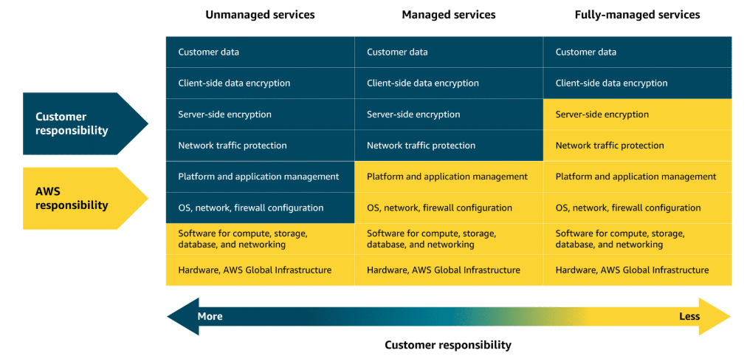

Lambda - Lambda is a serverless compute service that runs code in response to events triggers. It automatically manages the infrastructure, scaling and resource allocations based on the volume of requests.

Containers***-*** A container packages your application with everything it needs to run, so it works the same on any computer.

Containers with orchestration - They automate deployment, scaling, and management to keep everything running smoothly.

Amazon ECS - Amazon Elastic Container Service (Amazon ECS) is a scalable container orchestration service for running and managing containers on AWS, like Docker containers.

Amazon ECS launch types –

* Amazon ECS with Amazon EC2
* Amazon ECS with AWS Fargate (serverless)

Amazon EKS - Amazon Elastic Kubernetes Service (Amazon EKS) is a fully managed service for running Kubernetes on AWS.

Amazon ECR - Amazon Elastic Container Registry (Amazon ECR) is where you can store, manage, and deploy container images.

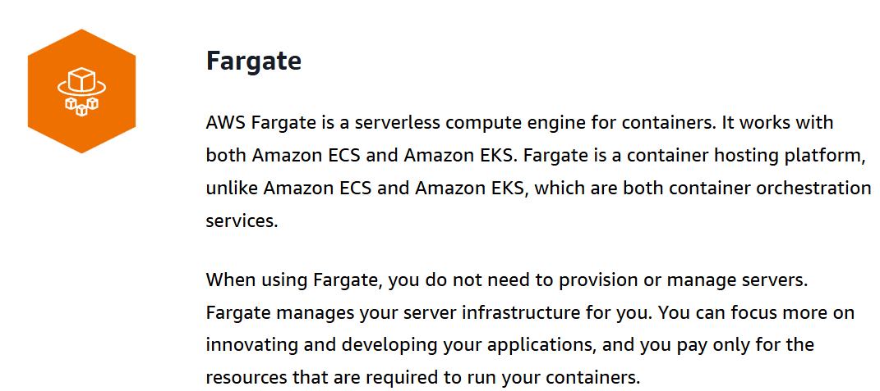

Elastic Beanstalk - Elastic Beanstalk is a fully managed service that streamlines the deployment, management, and scaling of web applications.

AWS Batch - AWS Batch is a fully managed service that you can use to run batch computing large workloads on AWS.

Lightsail - Amazon Lightsail is a cloud service offering virtual private servers (VPSs), storage, databases, and networking at a predictable monthly price.

Outposts - AWS Outposts is a fully managed hybrid cloud solution that extends AWS infrastructure and services to on-premises data centers.